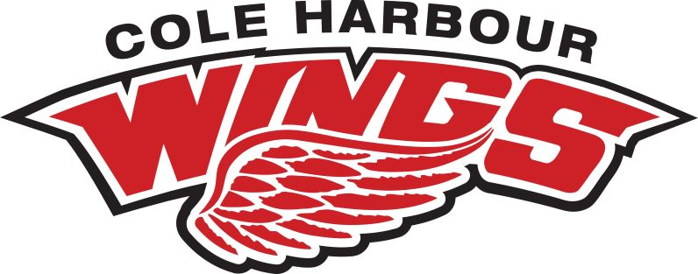
Corporate Sponsorship
TEAM:____________________________________

Branding & Promotion

• Logo/Brand recognition (8’x3’ banner) at all home games throughout the season
• Logo/Brand recognition on all team communications (digital and print)
• Logo/Brand recognition on our Facebook page, including 2 posts throughout the season
showcasing your business, specials or promotions with website or Facebook links.
• Any business coupons, giveaways, communications in a package can be handed out to
parents/fans at a home game once throughout the year.

Sponsorship Opportunities

Gold Level - $500

• Logo/Brand recognition (8’x3’ banner) at all home games throughout the season
• Logo/Brand recognition on all team communications (digital and print)
• Logo/Brand recognition on our Facebook page, including 2 posts throughout the season
showcasing your business, specials or promotions with website or Facebook links.
• Any business coupons, giveaways, communications in a package can be handed out to
parents/fans at a home game once throughout the year.

Silver Level - $250

• Logo/Brand recognition (8’x3’ banner) at home games throughout the season
• Logo/Brand recognition on our Facebook page, including 1 post throughout the season
showcasing your business, specials or promotions with website or Facebook links.

Bonze Level - $125

• Logo/Brand recognition on team banner

Contact

For additional information, please contact our Team Manager:
NAME:
PHONE NUMBER:
EMAIL:

Monetary Contribution Date

Team Representative Corporate Representative

